**ASSIGNMENT ON OSI MODEL AND TCP/IP MODEL NOTES AND DIFFERENCES BETWEEN THE TWO.**

**OSI MODEL.**

The OSI (Open System Interconnection) is a reference model for how messages should be transmitted between any two points in a telecommunication network.

Its purpose is to guide product implementers so that their products will consistently work with other products.

The reference model defines seven layers of functions that take place at each end of a communication.

The OSI reference model is a standard that is used to describe how network hardware and software work together in a layered fashion to make communications possible.

It also helps with troubleshooting by providing a frame of reference that describes how components are supposed to function.

The various hardware and software manufacturers design products based on the specification of the OSI model

**The relationship of OSI layers and the Seven Layers.**

The OSI layer consists of seven layers, with each layer covering different network activities, equipment, or protocols.

These layers are:

1. Layer 7: Application Layer
2. Layer 6: Presentation Layer
3. Layer 5: Session Layer
4. Layer 4: Transport Layer
5. Layer 3: Network Layer
6. Layer 2: Data Link Layer
7. Layer 1: Physical Layer

Each layer has a specific function and performs a value-added service at the request of the adjacent higher layer and, in turn, requests more basic services from the adjacent lower layer.

Below is an image representing examples of the upper layers and lower layers of the OSI model in action depending on its stage.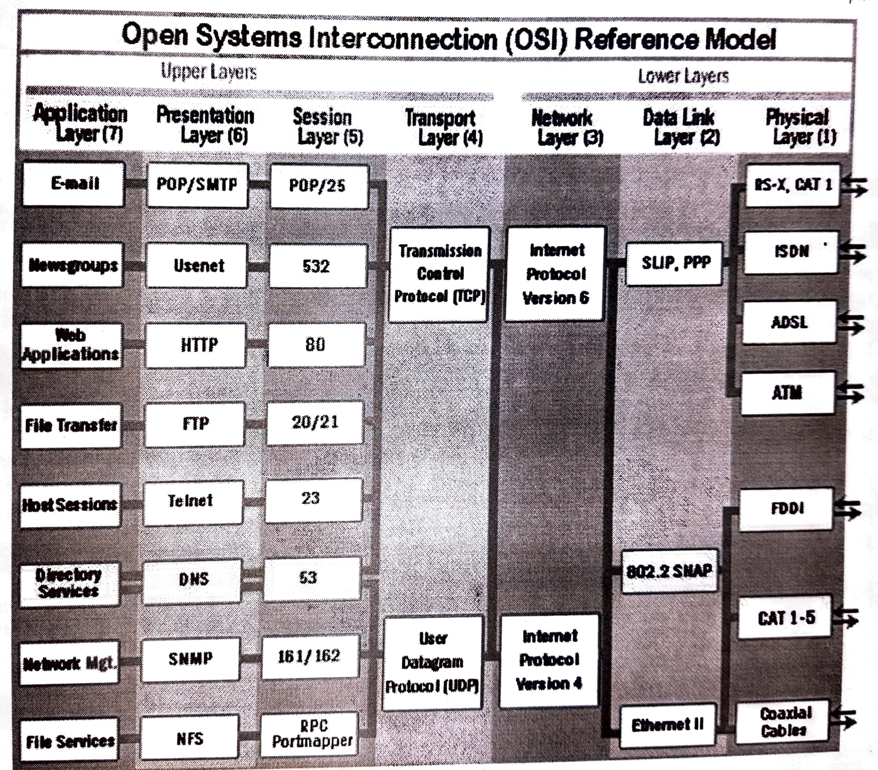

Below is a table summary of the seven layers and their description.

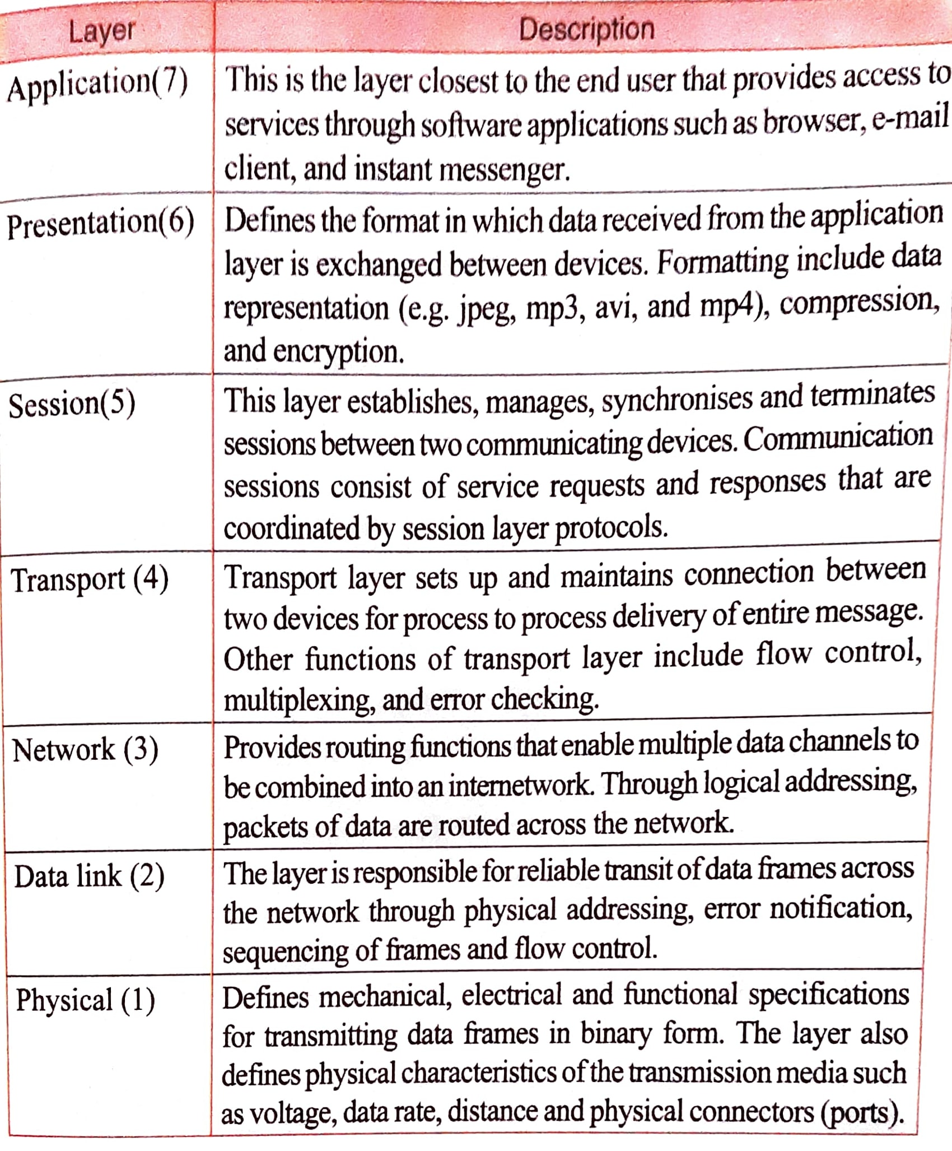

Because the OSI model is a framework, actual communication is made possible through the seven layers by the use of protocols. In the following section, I’ve highlighted some of the protocols used in each layer:

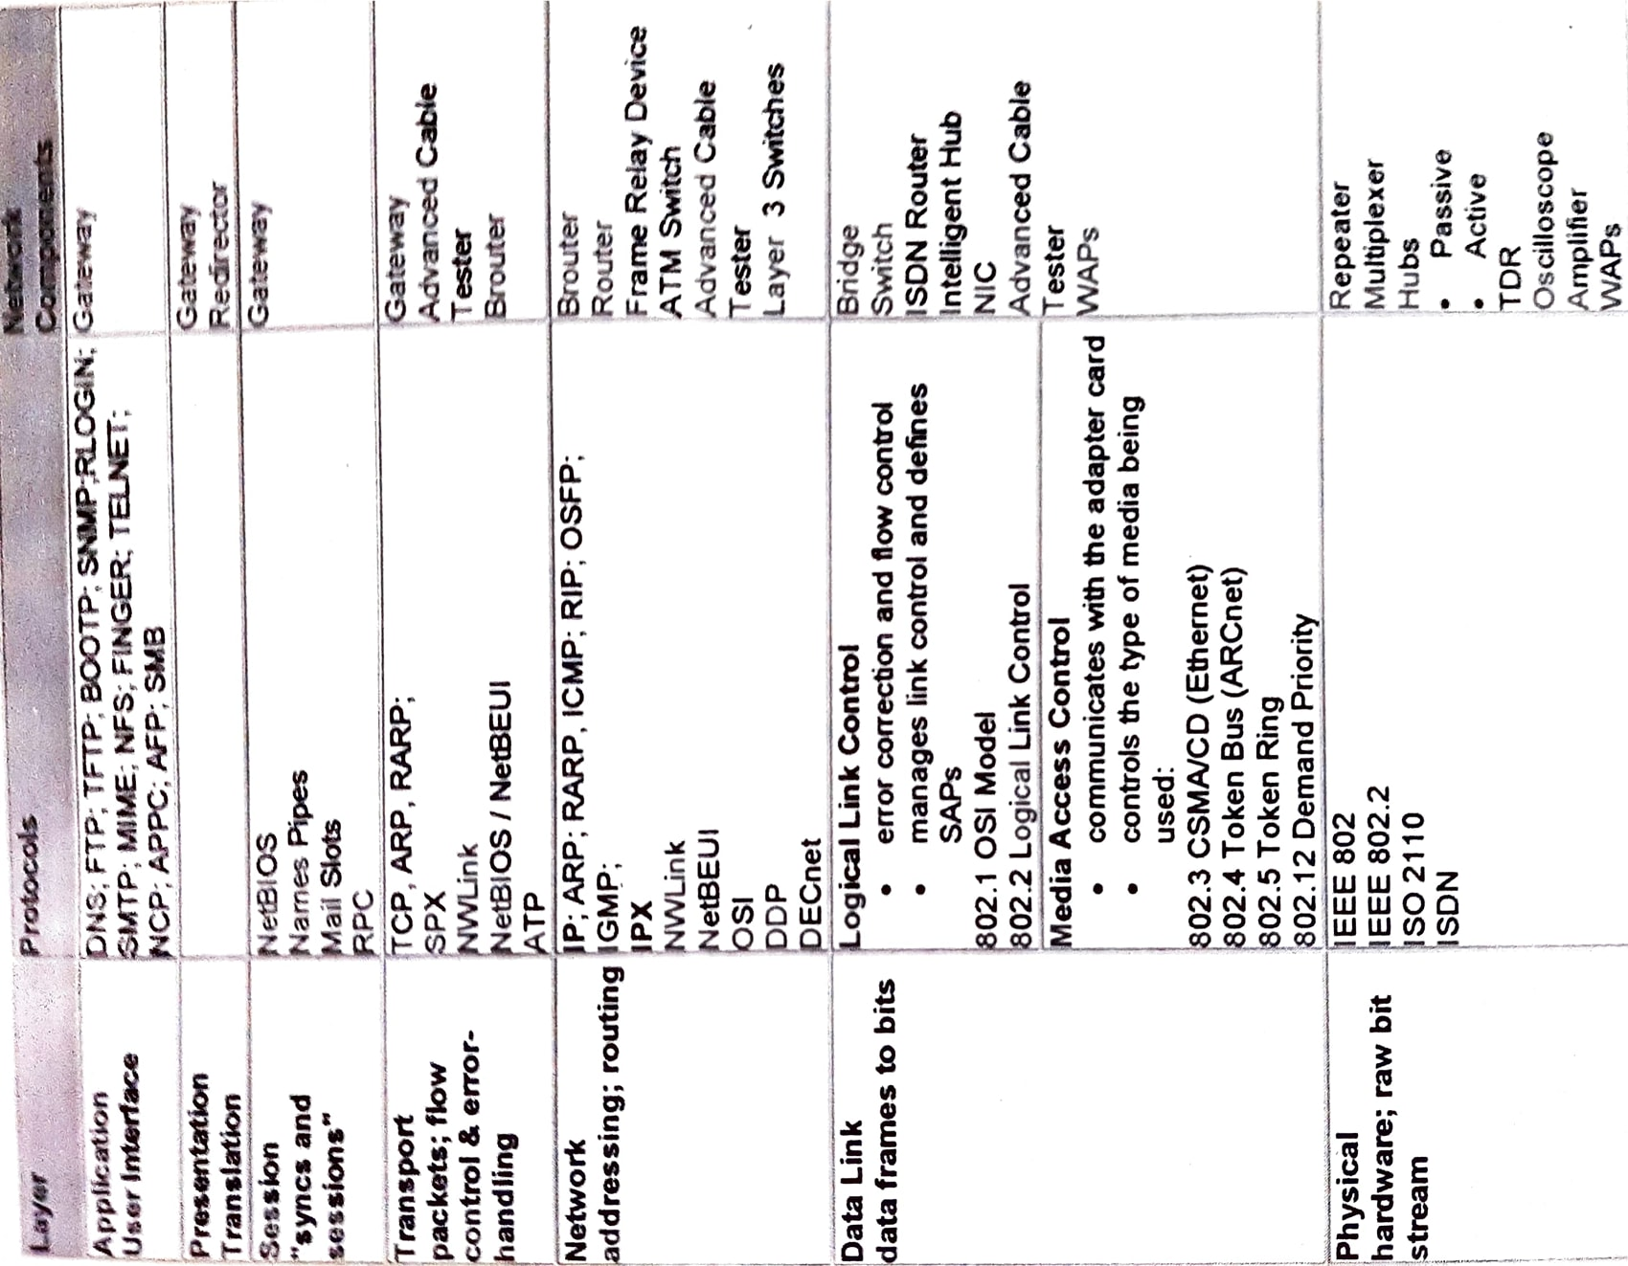

**TCP/IP MODEL.**

TCP/IP stands for Transmission Control Protocol/Internet Protocol. TCP/IP was originally designed for WANs, it is now widely used on LANs as well.

Packet switching refers to protocols in which messages are divided into packets before they are sent.

Each packet is then transmitted individually and can even follow different routes to its destination.

Once all the packets forming a message arrive at the destination, they are recompiled into the original message.

TCP/IP enables enterprise networking and connectivity of almost all network operating systems.

**TCP/IP protocol suite**

TCP/IP protocols map to a four-layer conceptual model: Application, Transport, Internet, and Network Interface.

This model is referred to as the “Internet Protocol Suite” or the ARPA model.

The figure below illustrates how each layer in the Internet Protocol Suite corresponds to one or more layers of the OSI model

C:\Users\mesha\AppData\Local\Microsoft\Windows\INetCache\Content.Word\Adobe Scan 24 May 2022 (3)_1.jpg

Datalink layer

The data link layer (also called the link layer, network interface layer, or physical layer) is what handles the physical parts of sending and receiving data using the Ethernet cable, wireless network, network interface card, and device driver in the computer, and so on.

Network Layer (Internet layer)

Internet protocols encapsulate packets into the internet datagrams and run all the necessary routing algorithms

The four internet protocols are Internet Protocol, Address Resolution Protocol, Internet Control Message Protocol, and Internet Group Management Protocol.

* Address Resolution Protocol is responsible for obtaining hardware addresses and matching them to their IP address when the destination computer is on the same physical network.
* Internet Control Message Protocol is a message control and error-reporting protocol between a host server and a gateway to the internet.
* Internet Group Management Protocol provides a way for the internet computer to report its multicast group membership to adjust routers
* Internet Protocol is the method by which data is sent from one computer to another on the internet.

Transport layer

The transport layer is what provides a reliable data connection between two devices.

It divides the data into packets, acknowledges the packets that it has received from the other device, and makes sure that the other device acknowledges the packets it receives.

The two transport protocols are Transmission Control Protocol and User Datagram Protocol.

* Transmission Control Protocol provides connection-oriented, reliable communication for applications that typically transfer large amounts of data at one time or that require an acknowledgment for data received.
* User Datagram Protocol is a connectionless, non-guaranteed method of communication with no sequencing or flow control.

Application layer

The application layer is the group of applications that require network communication.

This is what the user typically interacts with, such as email and messaging.

Because the lower layers handle the details of communication, the applications don’t need to concern themselves with this.

It is also the layer where many TCP/IP services can be run e.g. FTP, HTTP, and SMTP.

Two application programming interfaces (APIs) are commonly used within the TCP/IP environment:

* Sockets services provide a standard application programming interface to many transport protocols such as TCP/IP and IPX.
* NetBIOS provides a standard interface to protocol that supports the NetBIOS naming and messaging services, such as TCP/IP NetBEUI

**Difference between OSI model and TCP/IP model.**

* OSI has 7 layers whereas TCP/IP has 4 layers.
* The OSI Model is a logical and conceptual model that defines network communication used by systems open to interconnection and communication with other systems, on the other hand, TCP/IP helps you to determine how a specific computer should be connected to the internet and how you can be transmitted between them.
* OSI header is 5 bytes whereas TCP/IP header size is 20 bytes.
* OSI refers to Open Systems Interconnection whereas TCP/IP refers to Transmission Control Protocol.
* OSI follows a vertical approach whereas TCP/IP follows a horizontal approach.
* OSI model, the transport layer, is only connection-oriented whereas the TCP/IP model is both connection-oriented and connectionless.
* OSI model is developed by ISO (International Standard Organization), whereas TCP Model is developed by ARPANET (Advanced Research Project Agency Network).
* OSI model helps you to standardize router, switch, motherboard, and other hardware whereas TCP/IP helps you to establish a connection between different types of computers.